COMPUTING LAB - II
ADVANCED SYSTEM SOFTWARE LAB - CSE 5261
MTech - CSE
Week - 2 Basics of Python Programming

Name : Rajat Jain
Reg No : 200913010

Lab Exercises:

1) Write a python program that -
a) creates the list [1,11,111,1111,...,111...1], where the entries have an ever
increasing number of ones, with the last entry having 100 ones.

Code

ones = []
for i in range(1,101):
ones.append(int('1'*i))
print(ones)

Output

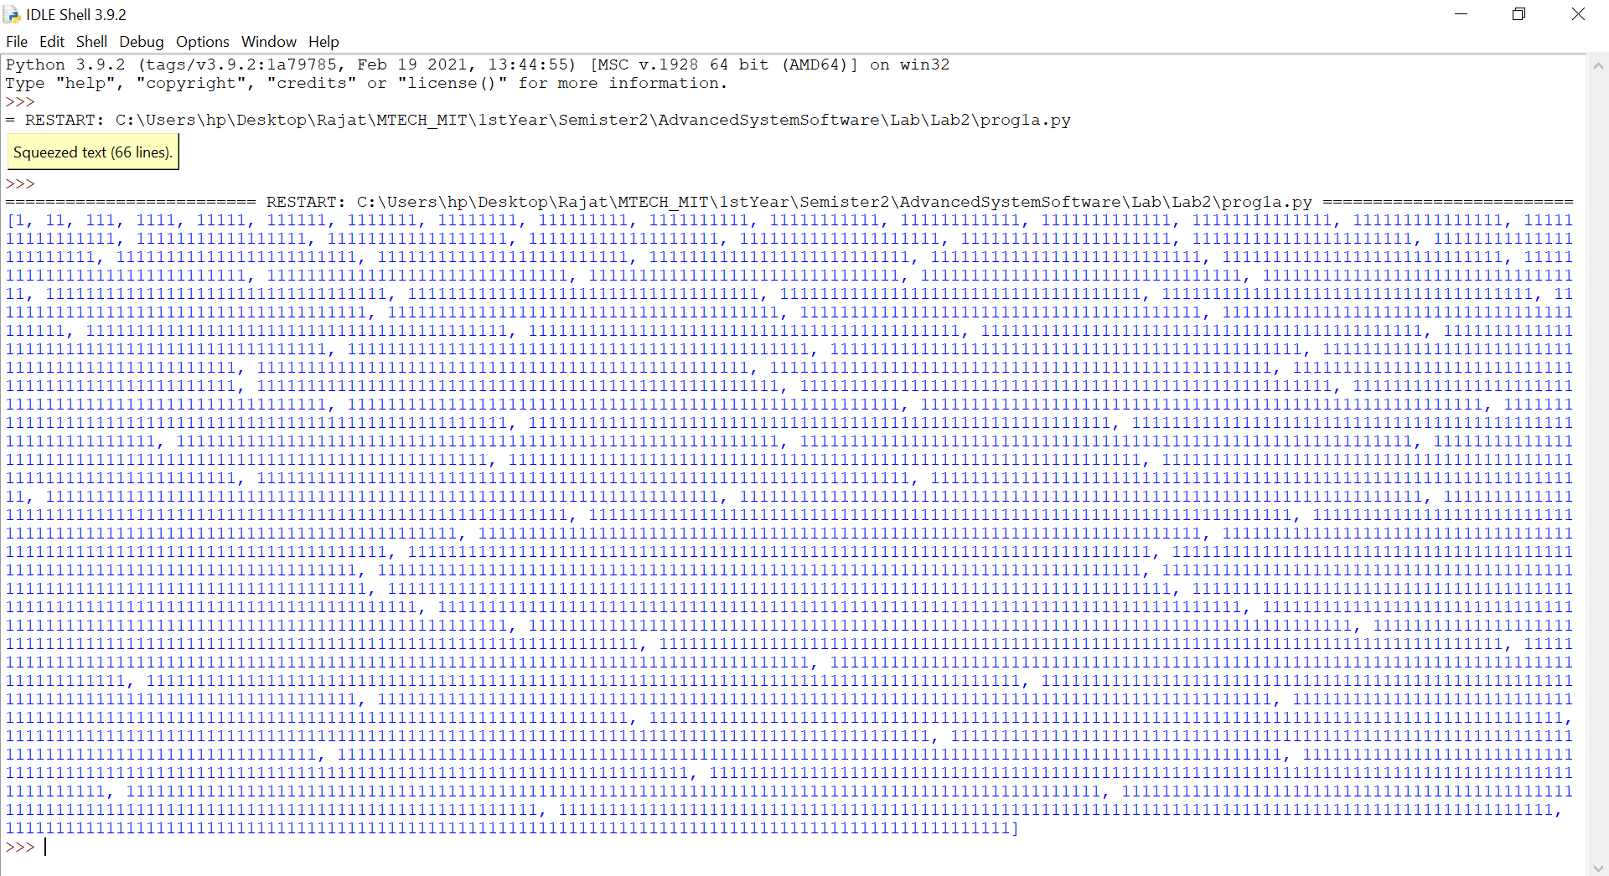

b) finds all pairs of six-digit palindromic numbers that are less than 20 apart.
One such pair is 199991 and 200002.

Code

pali=[]

def isPalindrome(s):
return s == s[::-1]

# Driver code
for i in range(100000,1000000):
ans = isPalindrome(str(i))

if ans:
pali.append(int(i))
else:
pass

for i in range(0,len(pali)):

j=i+1
while(j!=len(pali)):
if(pali[j]!=pali[i]):
if (pali[j] -pali[i] < 20) :

print(pali[i],pali[j])
j+=1

Output

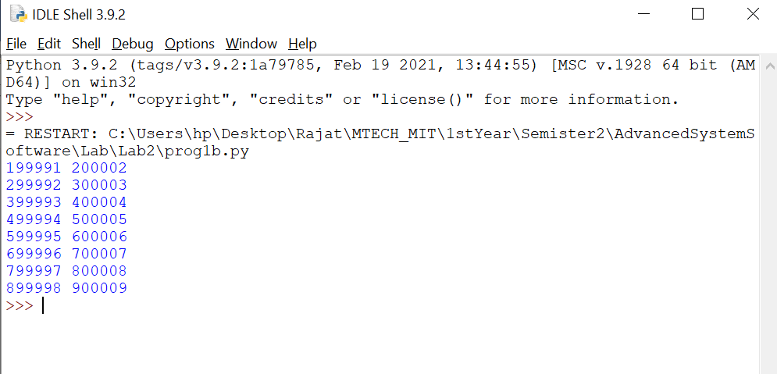

c) asks the user to enter a date in the format mm/dd/yy and converts it to a
more verbose format. For example, 02/04/77 should get converted into February 4,
1977.

Code

from datetime import datetime
date_input = input('Enter a date(mm/dd/yyyy): ')
date_object = datetime.strptime(date_input, '%m/%d/%Y')
print(date_object.strftime('%B %d, %Y'))

Output

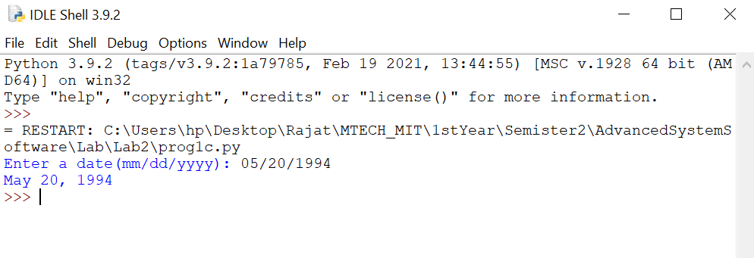

2) Write a program that asks the user to enter a word. Rearrange all the letters of
the word in alphabetical order and print out the resulting word. For example,
abracadabra should become aaaaabbcdrr.

Code

def rearrange(str):
return ''.join(sorted(str))

str = input("Enter the string: ")
print(rearrange(str))

Output

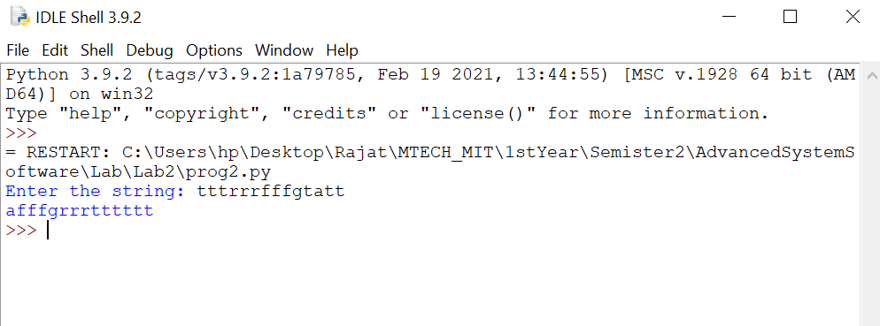

3) Create a 5 × 5 list of numbers. Then write a program that creates a dictionary whose keys are the numbers and whose values are the how many times the number occurs. Then print the three most common numbers

Code

import random
import itertools
import operator
five_dim = [[random.randint(1,5) for b in range(0,5)]for a in range(0,5)]
flat_list = [num for num in itertools.chain(*five_dim)]
key_set = set(flat_list)
freq_dict ={k: flat_list.count(k) for k in key_set}
x= sorted(freq_dict.items(), key = operator.itemgetter(1))[-3:]
print(f"The 5*5 list list is {five_dim}")
print(f"The dictionary is {freq_dict}")
print("The three most common numbers are : ")
for i in x:
print(i[0])

Output

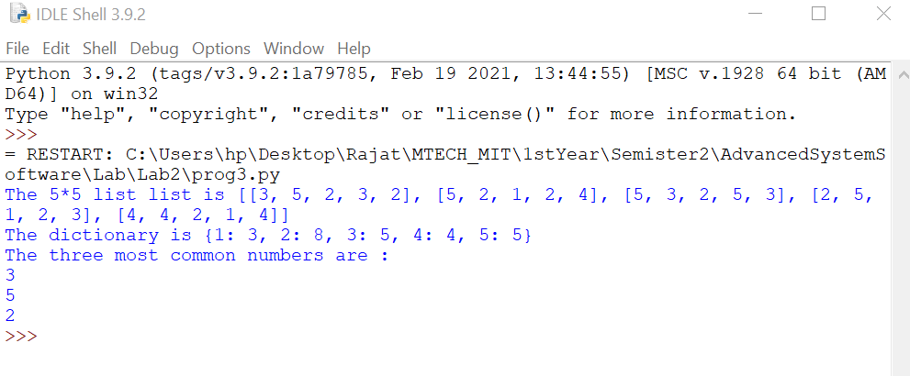
4) Write a Python program that uses a dictionary that contains ten user names
and passwords. The program should ask the user to enter their username and
password. If the username is not in the dictionary, the program should indicate
that the person is not a valid user of the system. If the username is in the
dictionary, but the user does not enter the right password, the program should
say that the password is invalid. If the password is correct, then the program
should tell the user that they are now logged in to the system.

Code

name_pass={"harish":"hari@2002","raghu":"r123@ghu","shri":"shri@98","ritesh":"ritz@2001","karthik":"kar@904","rajat":"rajat@1223","ashwin":"ash@1998","manisha":"manisha@1289","aditya":"desai@1992","anusha":"anusha@2002"}

login_name = str(input("Enter your username.\n"))
login_pass = str(input("Enter your password.\n"))
if login_name in name_pass.keys():
print("correct username.")
if login_pass == name_pass[login_name]:
print("Correct password")
print ("Logged in...!")
else:
print("Wrong password cannot login...")
else:
print("Wrong username cannot login...")

Output

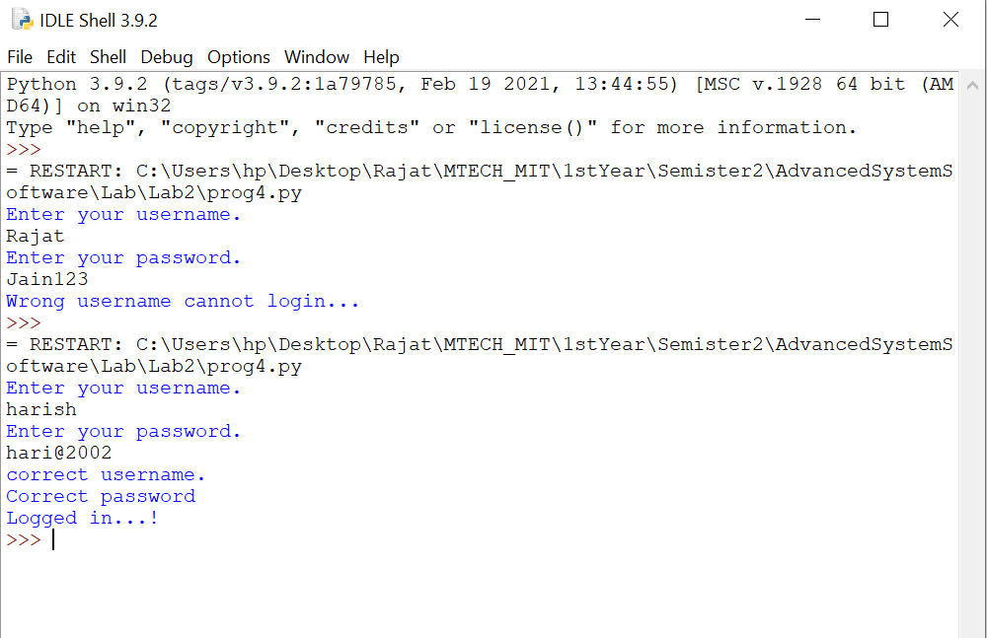

5) Suppose you are given the following list of strings:
L = ['aabaabac', 'cabaabca', 'aaabbcba', 'aabacbab', 'acababba']
Patterns like this show up in many places, including DNA sequencing. The user has a string of their own with only some letters filled in and the rest as asterisks. An example is a**a****. The user would like to know which of the strings in the list fit with their pattern. In the example just given, the matching strings are the first and fourth. Write a program to find the strings that match a user-entered string.
Code

s = input("Enter the string")
match_index = []
L = ['aabaabac', 'cabaabca', 'aaabbcba', 'aabacbab', 'acababba']
for i in range(len(L)):
match = True
for j in range(len(s)):
if s[j]!='*' and s[j]!=L[i][j]:
match = False
if(match):
match_index.append(i+1)
print("The strings in the list which match the user string are : ")
for x in match_index:
print(x)

Output

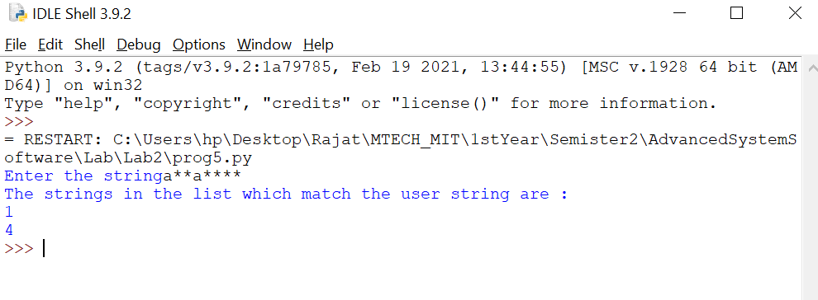
6) You are given a file namelist.txt that contains a bunch of names. Some of the
names are a first name and a last name separated by spaces, like George
Washington, while others have a middle name, like John Quincy Adams. There are no names consisting of just one word or more than three words. Write a program that asks the user to enter initials, like GW or JQA, and prints all the names that match those initials. Note that initials like JA should match both John Adams and John Quincy Adams.

Code

with open("namelist.txt") as n:
s = n.readlines()
lines = [line.strip() for line in s]
str_data = [line.split(" ") for line in lines]
Init = (input("Enter User Initial: "))
initial = list(Init)

for list in str_data:
if len(initial)>=2:
if len(list)==3:
if initial[0] == list[0][:1] and initial[1] == list[1][:1] or initial[1] == list[2][:1]:
print(list)
elif len(list)==2:
if initial[0] == list[0][:1] and initial[1] == list[1][:1]:
print(list)
else :
print("Enter either two or three initials")
break

Output

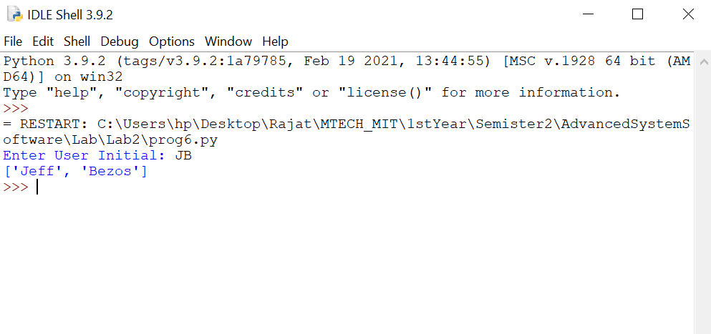
7) You are given a file called students.txt. A typical line in the file looks like:
Walter melon melon@email.msmary.edu 555-3141
There is a name, an email address, and a phone number, each separated by
tabs. Write a Python program that reads through the file line-by-line, and for
each line, capitalizes the first letter of the first and last name and adds the area
code 301 to the phone number. Your program should write this to a new file
called students2.txt. Here is what the first line of the new file should look like:
Walter Melon melon@email.msmary.edu 301-555-3141
CSE 5261 Page 2 of 2

Code

file=open("student.txt",'r')
file2=open("student2.txt",'w')
l=[]
for i in file:
r=i.split()
file2.write(r[0].capitalize()+" "+r[1].capitalize()+" "+r[2]+" "+"301-"+r[3]+"\n")
file.close()
file2.close()

Output

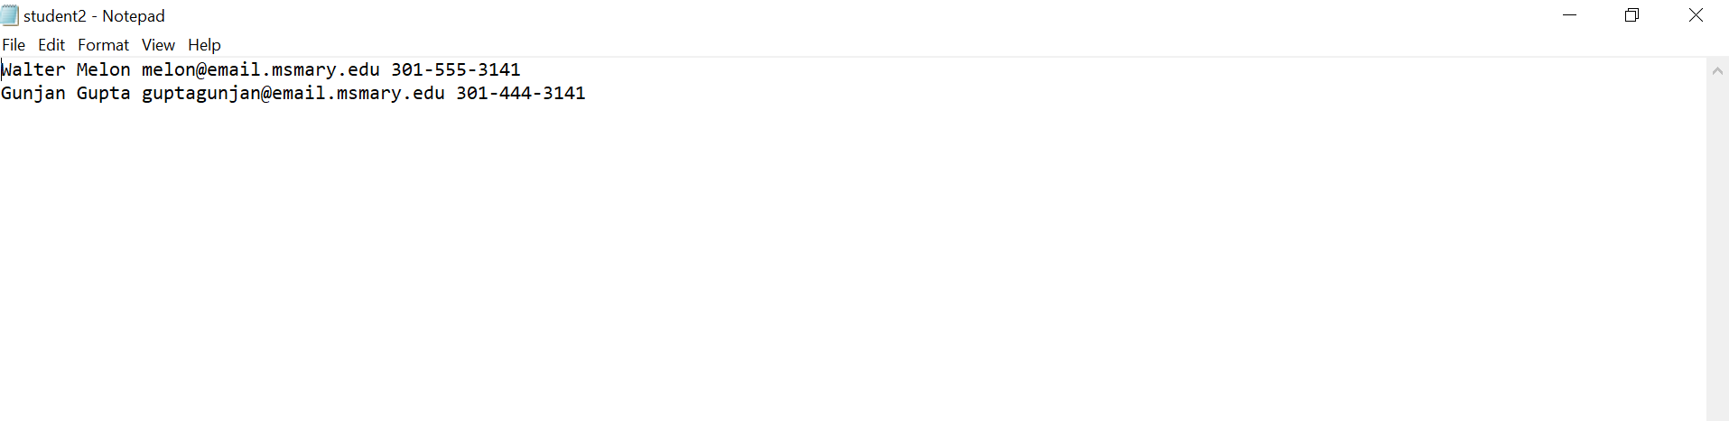

8) Write a function called closest that takes a list of numbers L and a number n and returns the largest element in L that is not larger than n. For instance, if
L=[1,6,3,9,11] and n=8,then the function should return 6, because 6 is the closest thing in L to 8 that is not larger than 8.

Code

def closest(l,n):
x = [b for b in l if n>b]
return max(x)
res = closest([1,6,3,9,11],8)
print(res)

Output

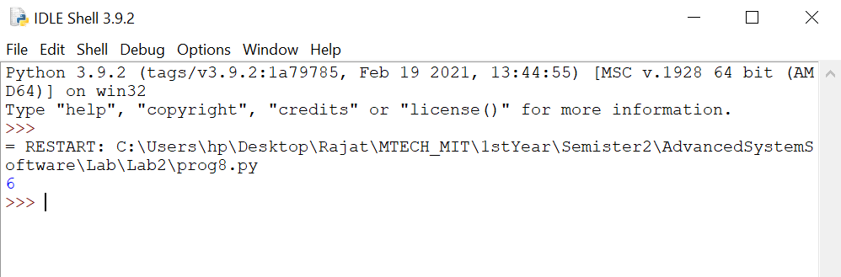

9) The digital root of a number n is obtained as follows: Add up the digits n to get a new number. Add up the digits of that to get another new number. Keep doing this until you get a number that has only one digit. That number is the digital root. For example, if n = 45893, we add up the digits to get 4 + 5 + 8 + 9 + 3 = 29. We then add up the digits of 29 to get 2 + 9 = 11. We then add up the digits of 11 to get 1 + 1 = 2. Since 2 has only one digit, 2 is our digital root.
Write a function that returns the digital root of an integer n. [Note: there is a
shortcut, where the digital root is equal to n mod 9, but do not use that here.]

Code

num = input("Ener the number")
num1 = num
while int(num)>9:
sum = 0
for digit in str(num):
sum+=int(digit)
num=sum
print(f"The digital root of the number {num1} is {sum}")

Output

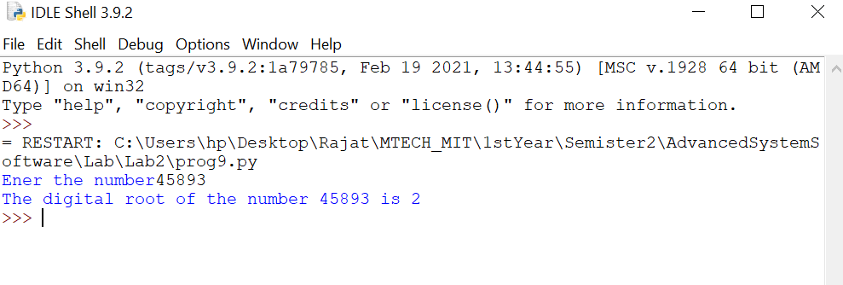

10) Write a function called first_diff that is given two strings and returns the first location in which the strings differ. If the strings are identical, it should return -1.

Code

def first_diff(s1,s2):
if s1==s2:
return -1
else:
l1 = len(s1)
l2 = len(s2)
for i in range(min(l1,l2)):
if s1[i]!=s2[i]:
return(i)
location = first_diff('Rajat','Rajeev')
if location==-1:
print("The two strings are same")
else:
print(f"The two strings first differ in the location {location}")

Output

